Submission 1:
HTML:
Tried out some different sizes of text after setting up the basic html file buildup, needed some help with the right order of when you write what. Tried to make it visible in the vs code program and found out about the tab system in vs code. Haven’t found a save button yet besides cmd + s but theres also no ui element showing I have saved it or its not saved, that’s something I’m missing. Played around with dropdown menu for the styles of text.

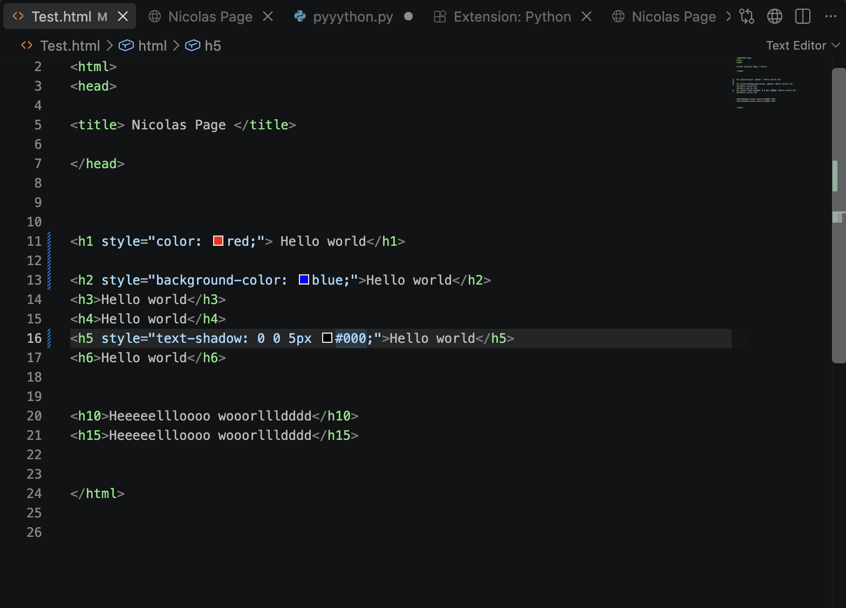
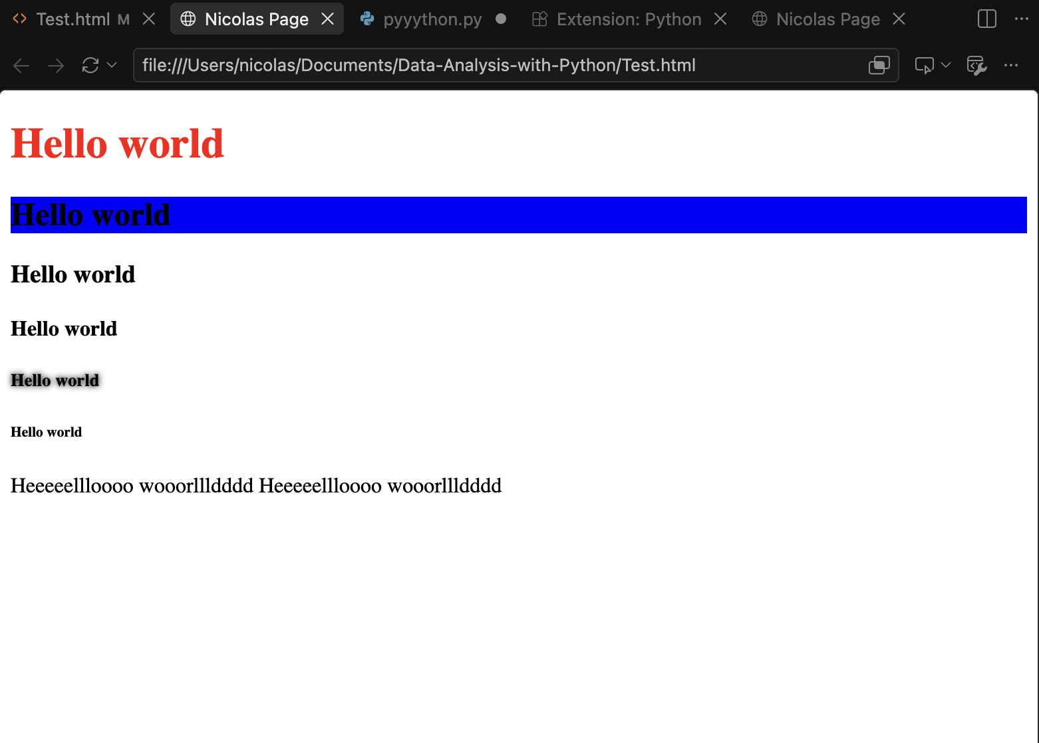
Python:
Read through the W3 Schools free course again after I had done of it some time ago and tried my best with some while if else loops with numbers and variables and print messages.
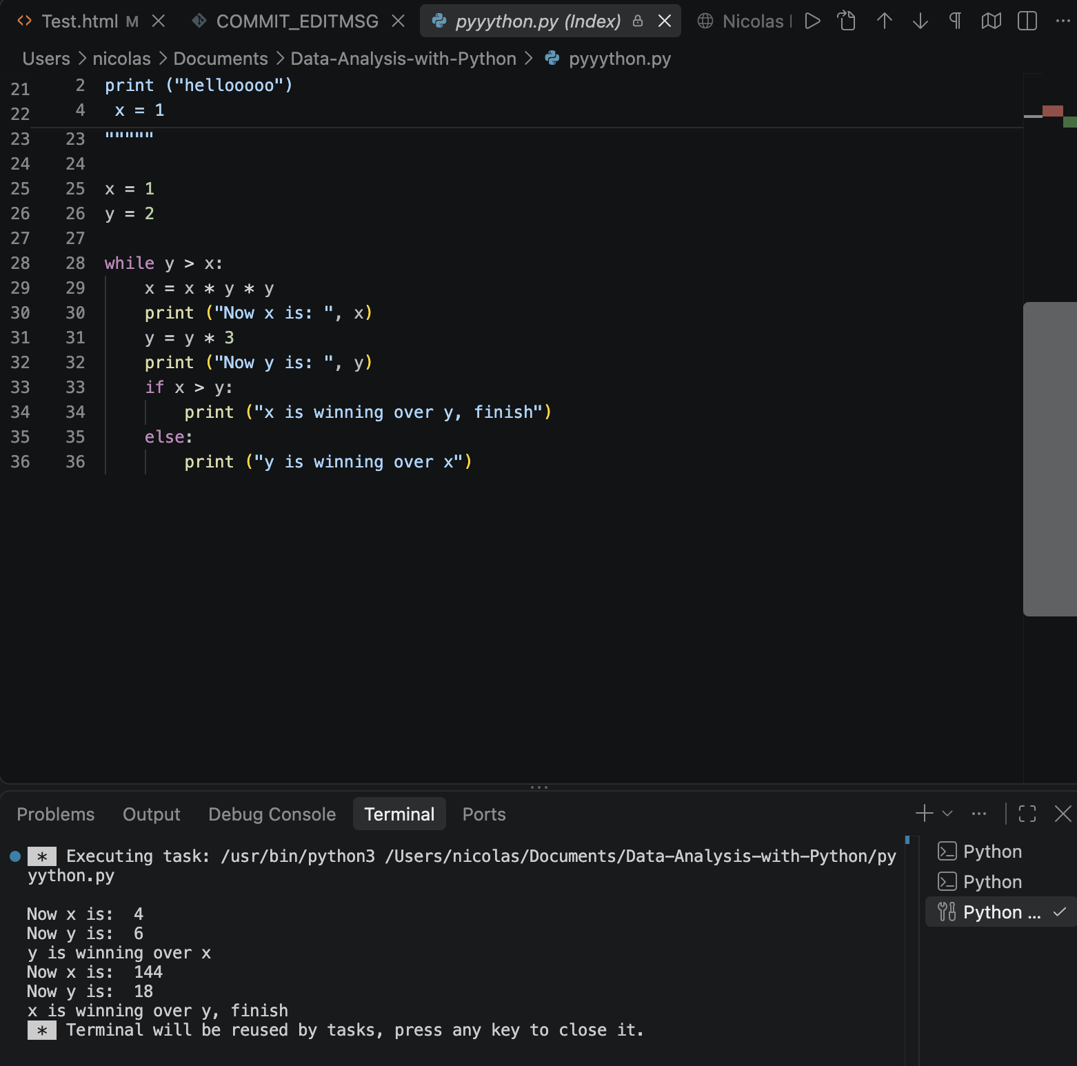
Most interesting:
The git/github video since I didn’t know really anything about it before, hardest was understanding the environment of the vs code program and connecting all to the github stuff. Took me some online search and tutorials so that my files are pushed and synced and not just saved. But I still don’t understand it really.
How some broken python is still in my head but not really, and how this is really demanding but also helps since I kind of know the intention what I want, how to set it up structurally and what is possible so far, but not super safe in how to write it correctly the first time.

Most difficult:
Getting Git and Github work and connect to the laptop and to vs code.
Pushing, commit and sync files in vs code, I had to add some kind of name for it to save.

To do for next week:
- understand the vs code environment more: I find all the subtabs and buttons confusing, I notice the limit of things is way too high, too many buttons and different ways to do things it seems. Just writing code and syncing it is not that user friendly for a beginner. Just getting familiar with the most necessary things I need to do in vs code would be very useful, for me everything in the ui looks pretty much the same.

